# Remotely developing an application for specialised equipment. (A Freelancer Case Study)

(Project Origin: Cyprus – Hiring a developer from abroad)

This project involved creating an application designed specifically for a specific touch tabletop device taking advantage of some of its specialised features; namely, the Samsung Surface (ex Microsoft Surface Version 2) – See figure 1. The device is stored in Cyprus, at the Cyprus Interaction Laboratory (http://www.cyprusinteractionlab.com) and is only allowed to be used / programmed by a limited number of personnel.

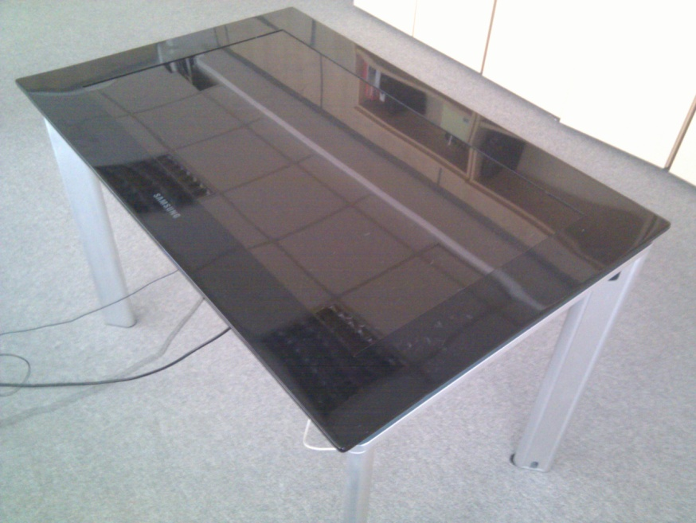

Figure : Samsung Tabletop Surface

The project was needed for a non-profit cause in the higher education industry – Cyprus University of Technology. The application (named ideaSpace) would be used in order to facilitate collaborative prototyping and creativity among individuals. The project was vital in the development of the community as a previous prototype facilitated successful collaboration between people from different nations and also opposing country members in which their existed a conflict and political differences. The previous application was able to bring together peoples from these opposing nations to successfully collaborate on peace issues. It was therefore critical to be able to develop a second more advanced version to continue making strides in improving the relationships of different international nations.

We began to post and advertise for programmers with the skills to code the required application for the device. To our disappointment we were unable to secure anyone on the island with the required skills to undertake this project. I then remembered that a friend had recommended freelancer as a repository for talented individuals with a wide range of abilities and at reasonable prices. After approval was given to outsource the project abroad, we uploaded the requirements on freelancer and created a project in the hope of finding suitable and able developer.

We were able to upload a requirements documents since the project needed a more intricate deliverables list easily, which was one of our primary concerns.

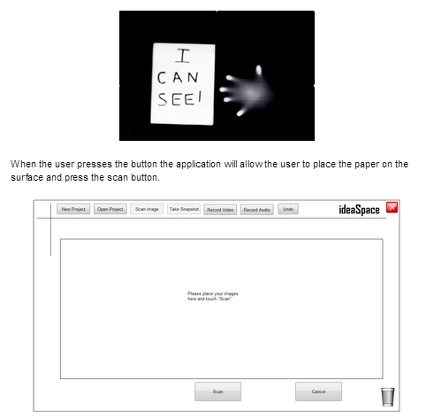

Figure :Part of the Requirements Document

Despite the complexity of the project we had over 1000 views (most within the first few hours of posting) and 11 BIDS close to the price we were asking. We were able to then go through each of the bidder’s profiles and select our top picks. Freelancer allowed us to communicate with the developers directly in order to ask them a few questions (sort of an informal interview) and help us therefore make a selection. After selecting the programmer of choice, we were easily able to come to a compromise on time and price with Freelancer tools.

During the project we needed to facilitate for remote development and testing since the machine was located half way around the world from the developer. This was done using team viewer and a live camera feed to the developer who developed directly into a shared drop box folder. Communication was done via the freelancer messaging system which conveniently sent the messages to e-mail to notify us of new developments. Weekly meetings were setup and minutes kept on the freelancer website. The process was also highly iterative using a user centred design approach. This meant several re designs and testing to achieve the final outcome.

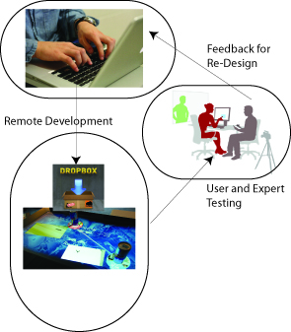

Figure : A highly iterative User-Centred Design Approach

This was a big project with a difficult working methodology being a remote project on a device which is not readily available and so was not available at hand for the developer to work locally on. Furthermore, the specialisation of the hardware made using Forums and other resources difficult as there were scarce information. Both sides were needed for testing and feedback was sent back again through the messaging system of freelancer which facilitated picture messaging also, vital for the project’s success.

During the project it was evident that deliverables needed to be split up further into smaller modules. Upon agreement, these were easily changed again with the freelancer interface. Beyond the difficulties, the developer was able to deliver based on exact requirements. He grasped the need directly and executed smoothly.

Finally, we were able to complete the project successfully. The application is now running and being used for testing from several groups of individuals including opposing country members, political rivals and children, in order to teach group work and fairness. The results will be published in international research journals and articles worldwide.

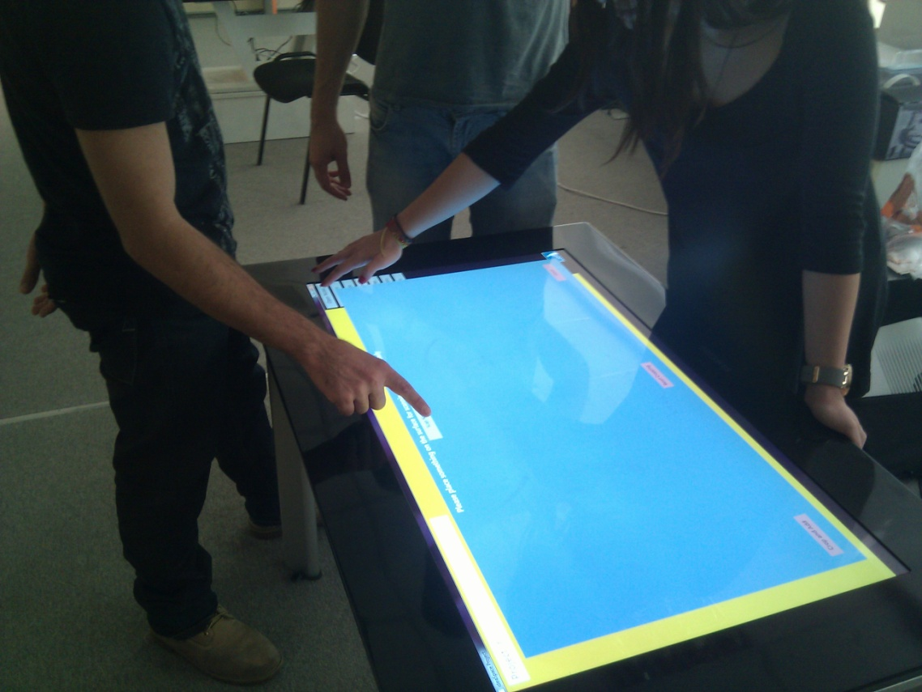

Figure : Users Using ideaSpace V1.0

Overall impressions of using freelancer were excellent. This was the first time using freelancer and the project posted cost an excess of 4000 USD. The more we used freelancer though the more our minds were set at ease. The process to join and sign up was straight forward and posting a project was fast. The communication capabilities facilitated effective feedback for the developer from the central lab. We will definitely be using freelancer in the future to find expertise and skills needed.

Dr. Fernando Loizides

Dept. of Multimedia and Graphic Arts

Cyprus University of Technology